Plants in space: GRAVI-2 experiment

V. Pereda-Loth¹, I. Karoliussen², B. Eche¹, J. Gérard³ and V. Legué⁴

¹V. Pereda-Campos and B. Eche, GSBMS, Toulouse University 133 Route de Narbonne, 31063 Toulouse, France. ²I. Karoliussen, Centre for Interdisciplinary Research in Space (CIRiS), NTNU Samfunnsforskning, Trondheim, Norway. ³J. Gérard, Lorraine University, UMR INRA/UL 1137 EEF BP 239, 54506 Vandoeuvre Les Nancy Cedex, France. ⁴V. Legué, Clermont Université, University Blaise Pascal, UMR INRA/Clermont Université 547 PIAF, 24 avenue des Landais, BP 80026, 63171 Aubière Cedex, France
Contact: valerie.legue@univ-bpclermont.fr

Abstract:

Gravity is considered to be an important environmental factor in the orientation of plant growth. In the case of roots, signal gravity is perceived by specialized cells located in the root apex and, so called statocytes. Even if it is well known that the movements of amyloplasts (located in the statocytes) induce a series of signalling pathways, the role of amyloplasts displacement is not clearly elucidated. The objective of the GRAVI-2 project is to study the impact of amyloplasts displacement on the calcium-dependant pathways and thus, better understanding the gravity perception in lentil roots. The Gravi-2 experiment was launched on flight SpaceX3 in April 2014 (http://lensesinspace.wordpress.com/) and was performed on-board the ISS in May 2014 with EMCS (European Modular Cultivation System). Lentil seeds were germinated on the International Space Station (ISS) in different situations: (1) continuously in microgravity conditions (e.g. 10⁻⁴ g), (2) 10⁻² g during 8 hours after a growth period of 23 hours in microgravity, (3) 2g during 5 minutes after a growth period of around 31 hours in microgravity, and (4) 2g during 15 minutes after a growth period of around 31 hours in microgravity. The studies will be performed using complementary approaches including the analysis of amyloplast positioning, calcium localisation and the level of expression of genes.

1. Scientific context:
Plants have the ability to sense and to re-orient their growth in response to various stimuli including light, gravity, wind, humidity and mechanical stimuli. The response of a plant organ to a directional stimulus is called tropism. Even the magnitude of gravity seems to be constant on the surface of the earth, its direction and its magnitude might be affected by various factors like for example, wind for the stems and soil parameters for the root system. Therefore, gravitropism can be regarded as a crucial factor in the posture control of stems (Moulia and Fournier, 2011) and in the penetration for roots into the soil (Roy and Basshamm, 2014).
In roots, specialized sensory cells (called statocytes) located in the root apex perceive signal gravity. Upon a gravistimulation, a change in the polarity of cell perceiving gravity signal was observed with an amyloplast sedimentation on the peripheral side (Perbal and Driss-Ecole, 2003). Transduction pathways were immediately activated with changes of calcium-dependant pathways. In parallel, many studies have demonstrated that cytoplasmic free Ca ²⁺ concentration is affected by environmental stimuli. The regulation of this homeostasis involves a series of transduction events such as the synthesis and activation of calcium binding and targeted proteins including calmodulin proteins.

2. The objective of the GRAVI experiment:
In this first part of GRAVI experiment (GRAVI-1), the threshold acceleration and the presentation dose of the gravitropic reaction of lentil (Lens culinaris L. cv. Anicia) seedlings grown in microgravity (Driss-Ecole et al., 2008) were determined. Following a period of growth in microgravity conditions, seedlings were subjected to low accelerations for several hours. During root growth, the root orientation and curvatures were followed by time-lapse photography combined with still images downlinked in near real time to ground. The position of the root tip and the root curvature were analysed as a function of time. Based on this, the GRAVI-1 team observed that the embryonic root curved strongly away from the cotyledons (automorphogenesis) in microgravity, and then from 17 hours to 30 hours slowly straightened out (autotropism). The threshold acceleration perceived by the roots was found to be around 2×10⁻³ g (Driss-Ecole et al., 2008).
Considering the results obtained from GRAVI-1, GRAVI-2 aimed to investigate the response of the lentil root curvature as a compromise using threshold levels between 0.01g and 2g. Since calcium is considered to be an important second messenger involved in root gravisensing, the Ca²⁺ localisation in statocytes will be in focus and related to the positioning of the amyloplasts. The regulation of calcium-downstream gene expression will be analysed.
3. Hardware and equipment

Both the GRAVI-1 and the GRAVI-2 experiment hardware were designed for integration into a dedicated Experiment Container (EC). The EC is developed to support biologically experiments inside the EMCS, a rotor based facility with 2 centrifuges and 8 exchangeable ECs. The main features of the EMCS include automatically operated life support systems (airflow, water, light and temperature) as well as a gas scrubber. The centrifuges allow for a controlled speed from 0-2 g, while the EMCS cameras provide video and pictures during the experiment runs.
The Gravi2 experiment unique equipment (EUE) includes the handler; each holding two separate Culture Chambers (CCs) and a Fixative Unit (FU) (Figure 1a and 1b). The EUE’s electrical connection and atmosphere uses the EC base to interface with the EMCS Holding Structure.
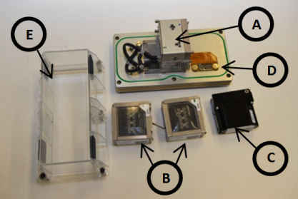
Figure 1a: The Gravi2 EUE consists of the Handler (A), the Culture Chambers (B) and the Fixative Unit (C). The EUE is mounted on the baseplate (D). The cover (E) and the baseplate (D) represent the Experiment Container.

Figure 1b: A detailed overview of a Culture Chamber including locations of the various penetration units.

The culture chambers contained 24 lentil seeds each, arranged in a linear fashion and kept in place by seed holders. The Fixative Units enclosed 38 mL of chemical fixative each; the chemicals were prepared and filled into the FUs while on ground. The handler is the interface between the CCs, FUs and EC baseplate and provides some very important functions. First of all, fixative and air interactions were operated via the penetration units (needles) inside the handler. Secondly, the handler electrical pumps allowed the chemical fixation to take place while the ECs were still on rotor and during various gravitational stimuli.
4. Scenario

The experiment specific goals are addressed in the design of two runs (Figure 1). Four fixatives with different science objectives for analysis are used:
- Fix #1: Analysis of amyloplast redistribution and cell ultrastructure using transmission electron microscopy.
- Fix #2: Studies of protein localisation using immunolocalisation methods in light and electron microscopy.
- Fix #3: Analysis of the localisation of free Ca²⁺
- Fix #4: Analysis of the level of target gene expression.

The Experiment Containers, the GRAVI-2 EUE and syringes prefilled with water for hydration, were packed and launched to the ISS. Crew initiated the experiment by manually injecting 4.5 mL of water into each CC, followed by the assembly of the hardware. The assembly took place inside the Biolab Glovebox, due to hazard level 2 of some of the fixative solutions. The fully assembled ECs were inserted inside the EMCS and the environmental control started (airflow and temperature). Pictures of the lentils from all CCs were taken every 20 minutes during the growth period that lasted approximately 30 hours,, see timeline (Figure 2) for details

Figure 2: The time line of GRAVI-2 experiment as performed in the European Modular Cultivation System (EMCS) on the International Space Station (ISS). The experiment initiated by a manual hydration of the Lentil seeds followed by an automated series of events including gravity stimuli and automatic fixation of samples in the centrifuge. At the end of the experiment, the astronaut removed the Experimental containers (EC) from the EMCS and then stored the Culture chambers (CC) at 4°C until the root sampling at Toulouse.

5. Conclusion

The GRAVI-2 operations were successful performed. Regarding the root growth, as expected and observed during the GRAVI-1 observations (Driss-Ecole et al., 2008), the embryonic root curved strongly away from the cotyledons, so called automorphogenesis (Figure 3). In some of the seedlings the root straightened out slowly (autotropism).
Microscopic and RNA-analyses on the samples started after the sample processing. First observations indicated a good preservation of the fixed tissues, as well as a good RNA fixation. The next step is to detect possible differences between the 4 gravitational exposures (0 g, 0.01 g, 1 g and 2 g).

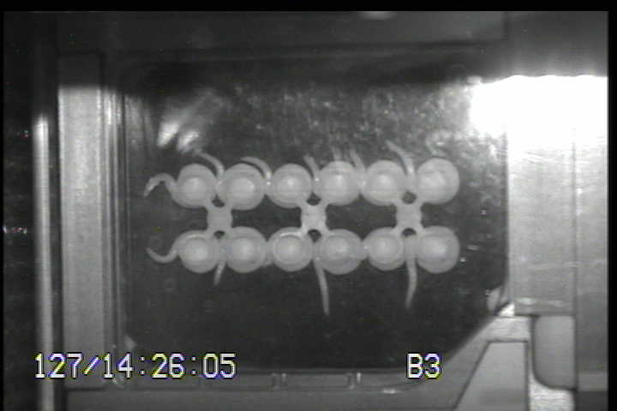
Figure 3: One picture obtained after 31 hrs of growth in microgravity (run 1)

Acknowledgment: the astronaut who has very carefully and successfully carried out our experiment in space; the N-USOC team for its considerable help in the preparation of the GRAVI experiment and for its technical support during the carrying out the experiment in ISS; Airbus team for the design and building of the hardware and control of EMCS during the experiment. This work should not have been possible without the scientific and financial support of ESA and CNES. The scientific team thanks G. Perbal and D. Driss-Ecole for invaluable advices; J. Franchel, N. Brunel, E. Bretecher (University of Clermont-Ferrand) and GSBMS team (University of Toulouse) for technical support.
References:

D. Driss-Ecole, V. Legué, E. Carnero-Diaz and G. Perbal, 2008. Gravisensitivity and automorphogenesis of lentil seedling roots grown on board the International Space Station. Physiologia Plantarum, 13, 191-201.

Moulia B. and Fournier M., 2009. The power and control of gravitropic movements in plants: a biochemical and systems view. J. Exp. Bot., 60, 461-486.

Perbal G. and Driss-Ecole D., 2003. Mechanotransduction in gravisensing cells. Trends Plant Science, 8, 498-504.

Roy and Basshamm, 2014. Root growth movements: waving and skewing. Plant Science, 221-222, 42-47.

